**A PROJECT REPORT**

**On**

**TechTube - “An E-learning website”**

**Submitted by**

**Roumodip Das (10800220004)**

**Abhishek Choudhary (10800220030)**

**Sneha Sarkar (10800220057)**

**Kunal Kesh (10800220025)**

**Under the Guidance of**

**Mr. Biplab Kumar Mondal**

**Asst. Professor**

**Asansol Engineering College**



**INFORMATION TECHNOLOGY**

**Asansol Engineering College**

**Asansol**

**Affiliated to**

**MAULANA ABUL KALAM AZAD UNIVERSITY OF TECHNOLOGY**

**06/24**



**CERTIFICATE**

Certified that this project report on **TechTube - “An E-learning website”** is the bonafide work of **“Roumodip Das(10800220004),Abhishek Choudhary (10800220030),Sneha Sarkar (10800220057),Kunal Kesh (10800220025)”** who carried out the project work under my supervision.

**Mr. Biplab Kumar Mondal Dr. Anup Kumar Mukhopadhyay**

Asst. Professor Asst. Professor (HOD)

Asansol Engineering College Information Technology

Asansol Engineering College

**INFORMATION TECHNOLOGY**

**Asansol Engineering College**

**Asansol**

**ACKNOWLEDGEMENT**

It is our great privilege to express my profound and sincere gratitude to our Project Supervisor Mr. Biplab Kumar Mondal, Asst. Professor ,Asansol Engineering College for providing me with very cooperative and precious guidance at every stage of the present project work being carried out under his supervision. His valuable advice and instructions in carrying out the present study have been a very rewarding and pleasurable experience that has greatly benefitted us throughout our work.

We would also like to pay our heartiest thanks and gratitude to Dr. Anup Kumar Mukhopadhyay, HoD, and all the faculty members of the Information Technology, Asansol Engineering College for various suggestions being provided in attaining success in our work.

We would like to express our earnest thanks to our colleagues along with all technical staff of the Information Technology, Asansol Engineering College for their valuable assistance being provided during our project work.

Finally, we would like to express our deep sense of gratitude to our parents for their constant motivation and support throughout our work.

……………………………………………

Roumodip Das

……………………………………………

Abhishek Choudhary

……………………………………………

Sneha Sarkar

……………………………………………

Kunal Kesh

**Date: <20/06/2024> 4th Year**

**Place: Asansol Information Technology**

**CONTENT**

Certificate ……………………………………………………………………………… ii

Acknowledgement ……………………………………………………………………... iii

Content …………………………………………………………………………………. iv

List of Figures/Table ………………………………………………………………….. v

Project Synopsis ………………………………………………………………………... vi

1. Abstract……………………………………………………………………. vi

2. Introduction ………………………………………………………………. vii

3. Project Details ……………………………………………………… viii – xix

3.1. Methodology (Data Flow Diagram)

3.2. Implementation Details

3.2.1. Hardware Requirements

3.2.2. Software Requirements

3.3. Languages Used

3.4. User Interface

4. Conclusion ………………….………………………………………… xx

5. Future Scope …………………………………………………………. xxi

6. Reference ……………………………………………………………… xxii

**LIST OF FIGURES**

|  |  |  |
| --- | --- | --- |
| Figure 1 | DFD Of the project Level 0 | viii |
| Figure 2 | DFD Of the project Level 1 | ix |
| Figure 3 | DFD Of the project Level 2 | ix |
| Figure 4 | Pie Chart on Languages used | x |
| Figure 5 | Home Page | xi |
| Figure 6 | About Page | xv |
| Figure 7 | Courses Page | xvi |
| Figure 8 | Playlist/Watch video page | xvii |
| Figure 9 | Teacher Page | xviii |
| Figure 10 | Contact Page | xix |
| Figure 11 | Dark Mode Student Portal | xix |
| Figure 12 | Admin Page (Login / Register) | xx |
| Figure 13 | Dashboard | xxi |
| Figure  14 | Playlist Page | xxii |
| Figure 15 | Content Page | xxiv |
| Figure 16 | View Comments Page | xxvi |
| Figure 17 | Search Courses | xxvi |
| Figure 18 | Dark Mode Admin Portal | xxvii |
| Figure 19 | Responsiveness Student Portal (mobile view) | xxviii |
| Figure 20 | Responsiveness Student Portal (Tab view) | xxviii |
| Figure 21 | Responsiveness Admin Portal (mobile view) | xxix |
| Figure 22 | Responsiveness Admin Portal (tab view) | xxix |

**PROJECT SYNOPSIS**

**ABSTRACT**

In the fast-paced digital landscape, the demand for flexible and accessible education is more significant than ever. "TechTube" emerges as a dynamic e-learning platform designed to transform the traditional learning experience. This project addresses the evolving educational needs of the modern learner by providing a comprehensive and interactive online environment.

TechTube is a user-centric e-learning website that offers a diverse range of courses, spanning from technology and programming to business and creativity. The platform is equipped with cutting-edge features, including high-quality video lectures, user friendly environment and user can utilize the content in offline mode.

**INTRODUCTION**

" This report illuminates the myriad advantages that this innovative learning platform brings to the forefront. From flexible accessibility and personalized learning paths to interactive content and global connectivity, explore how TechTube redefines the landscape of education for the better. This report embarks on an exploration of the manifold advantages inherent in this cutting-edge platform. One of the standout features of TechTube is its commitment to flexibility. Learners can access a wealth of educational content at their convenience, breaking free from traditional constraints of time and location. This flexibility not only accommodates diverse schedules but also fosters a learner-centric environment. Interactivity becomes a cornerstone of education with TechTube. Dynamic multimedia content, and collaborative tools such as students can ask doubts directly creates an immersive learning environment. This not only keeps learners actively engaged but also promotes a deeper understanding of the subject matter through hands-on experiences. Breaking down geographical barriers, the platform connects learners and educators from around the world, fostering a rich exchange of ideas and perspectives. This interconnectedness broadens the educational experience, offering a global perspective on various subjects. As we navigate through the depths of this report, we will uncover how TechTube's forward-thinking design and features contribute to an enriched and effective e-learning journey.

A Glimpse into TechTube:

* **Home Page**: Explore curated content, featured courses tailored to your interests.
* **About Page**: Discover the ethos and mission driving TechTube's commitment to reshaping online education.
* **Register/Login/Logout**: Seamlessly start your learning journey, ensuring your experience is secure and personalized.
* **View Profile**: Monitor your progress, achievements, and personalized settings effortlessly.
* **Update Profile**: Tailor your TechTube experience to reflect your unique learning preferences.
* **Course Page**: Immerse yourself in a diverse range of courses designed to empower and inspire learners.
* **Teacher Page**: Connect with experienced educators shaping the TechTube learning landscape.
* **Contact Us Page**: Access a direct line of communication for queries, support, and feedback Top of Form

**METHODOLOGY**

Techtube's e-learning workflow begins with user registration and profile setup, followed by course selection. Users access structured learning modules with diverse content, including videos and interactive elements. Progress is tracked, and assessments provide feedback. User support ensures a smooth learning experience, creating a comprehensive and effective e-learning journey.

Techtube's e-learning platform likely follows a structured methodology to deliver content effectively. It typically involves:

Needs Analysis: Identifying the target audience and their learning needs.

Content Creation: Developing high-quality educational content, which may include video lectures.

Platform Design: Creating an intuitive and user-friendly interface for easy navigation and engagement.

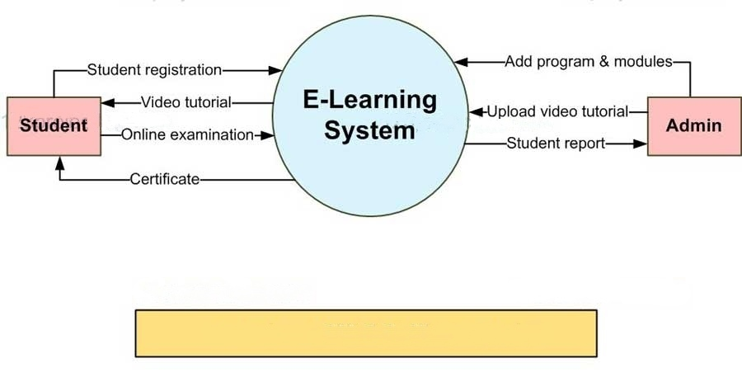

**Fig: 1 -**

**Level-0 DFD**

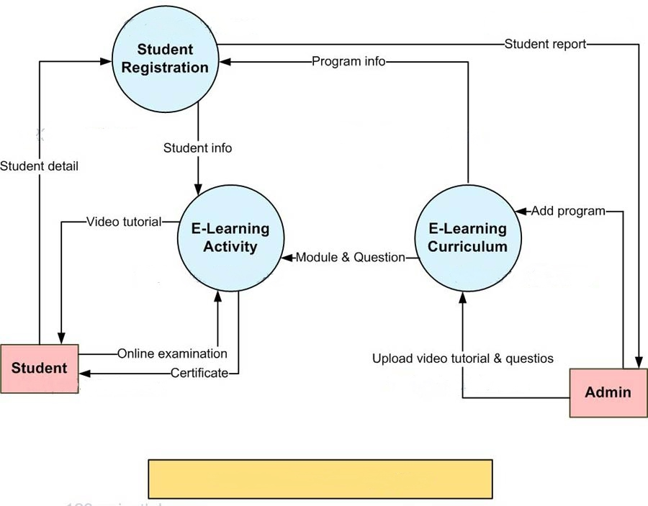

**Fig: 2**

**Level-1 DFD**

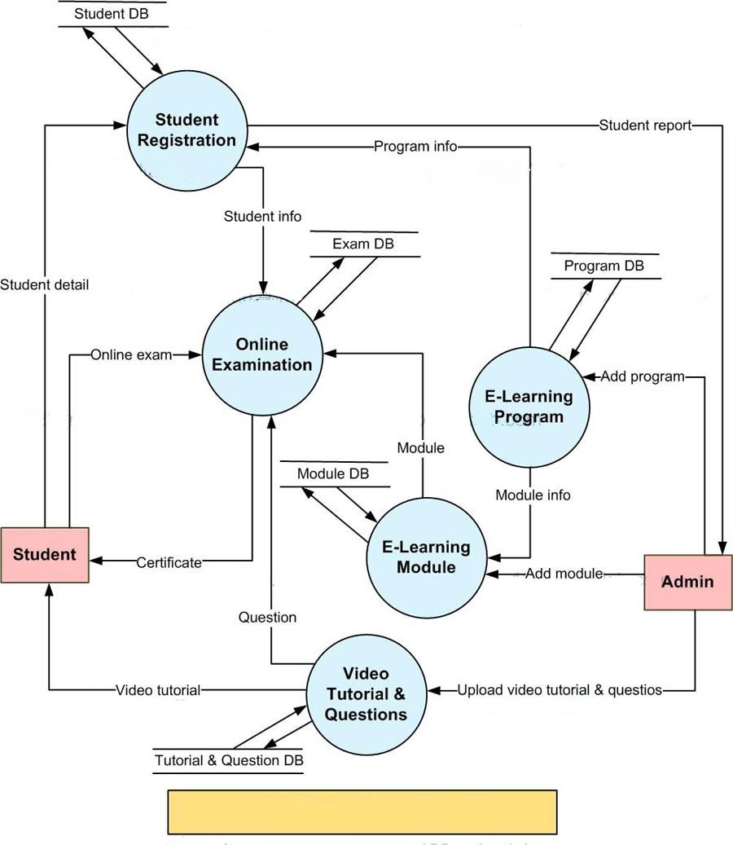

**Fig: 3**

**Level-2 DFD**

**IMPLEMENTATION DETAILS**

**Hardware Requirements:**

1. 4GB DDR4 RAM
2. 1TB Hard Drive
3. 8th Gen Intel Core i3-8145U 2.10GHz Processor

|  |  |
| --- | --- |
| Windows | 10 |
| Frontend-Languages | HTML5, CSS3 and JS |
| Backend-Languages | PHP 8.2 |
| Database | MySQL |
| Server | XAMPP Server 8.2 |
| IDLE | Visual Studio Code 9.8.1 |
| Browser | Google Chrome |

**Software Requirements:**

**Fig: 4**

**USER INTERFACE**

**Students Portal:**

**Home Page**

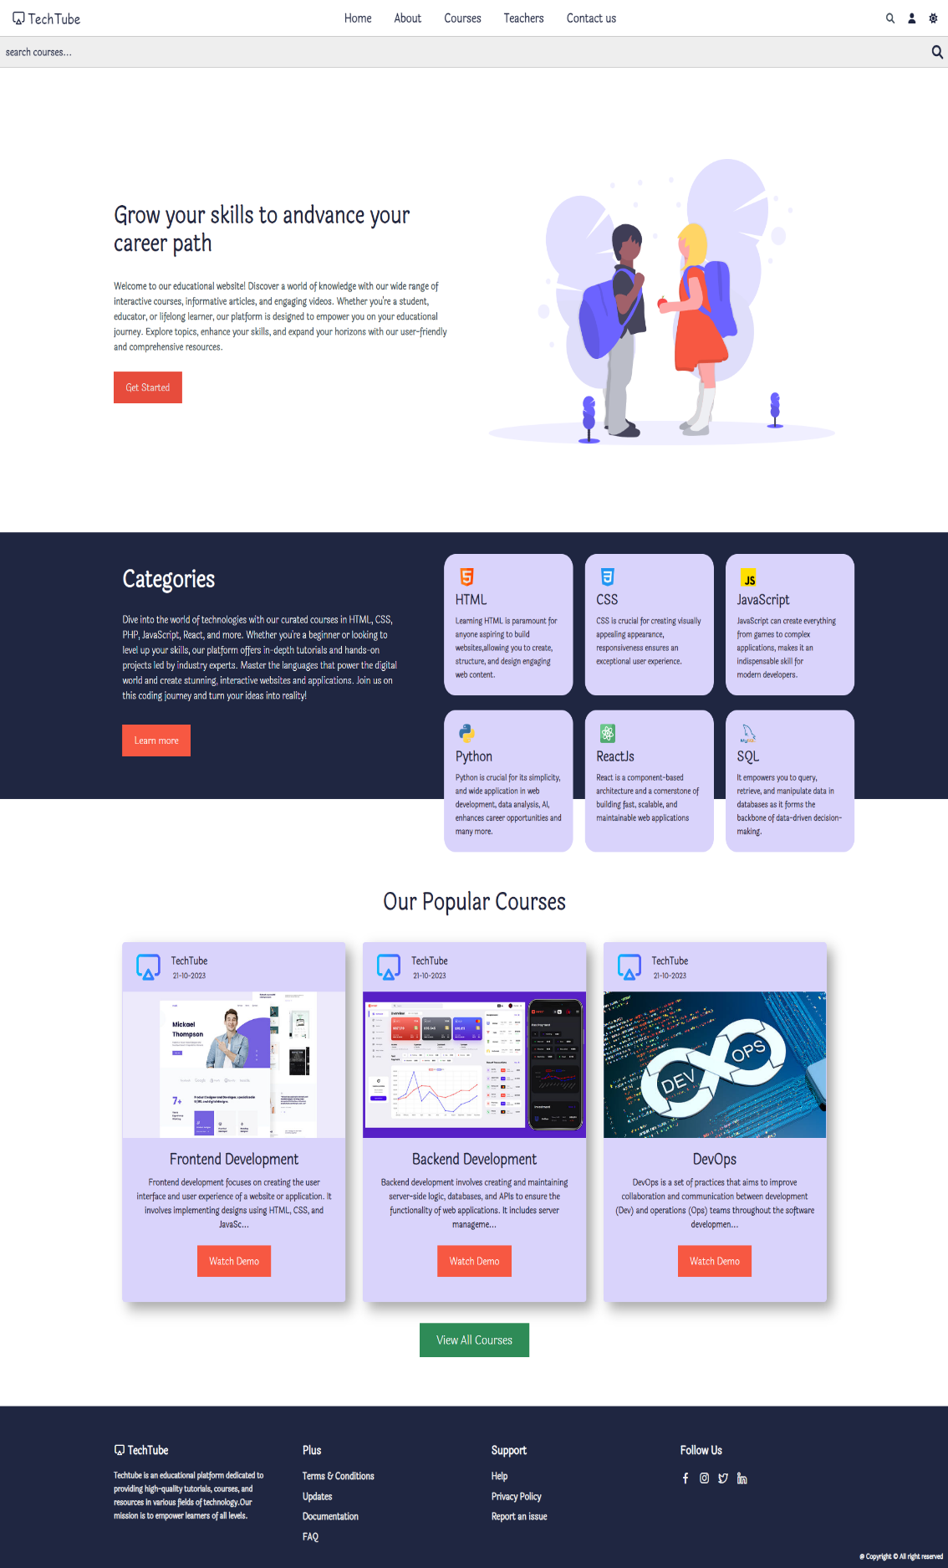

Search Bar

Nav Bar

Header Section

Redirects to the login page.

Categories Section

Redirects to the about page.

Courses Section

Redirects to the courses page.

**Fig: 5**

Footer Section

**Login/Register**

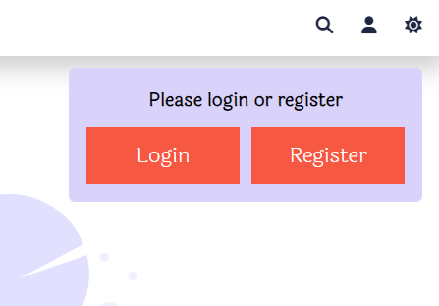

Redirects to login or register page accordingly.

**Fig: 5.1**

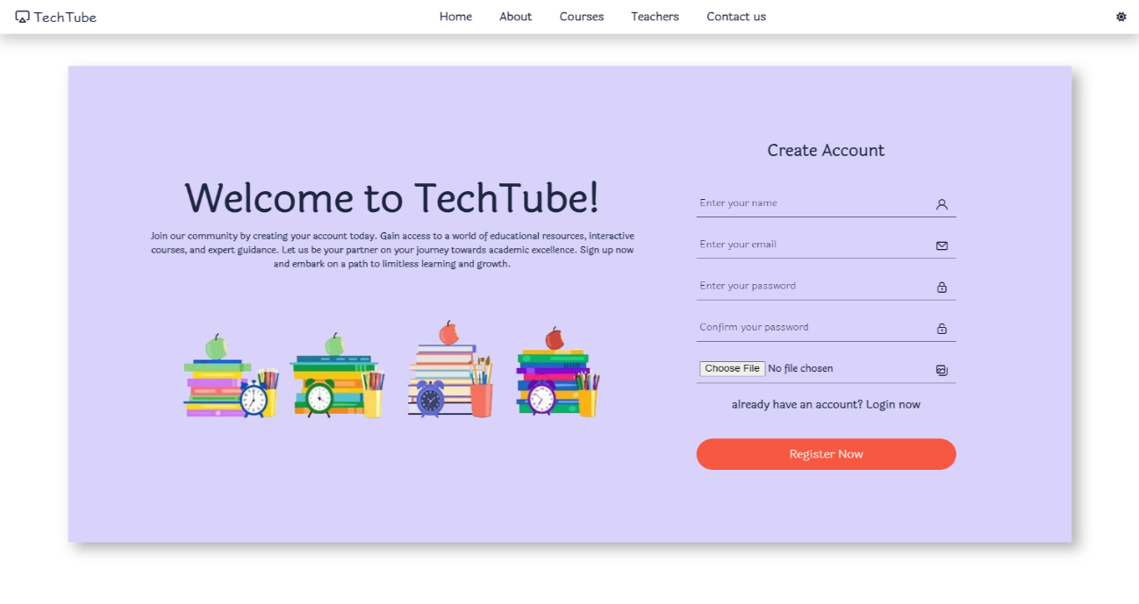

**Fig: 5.2**

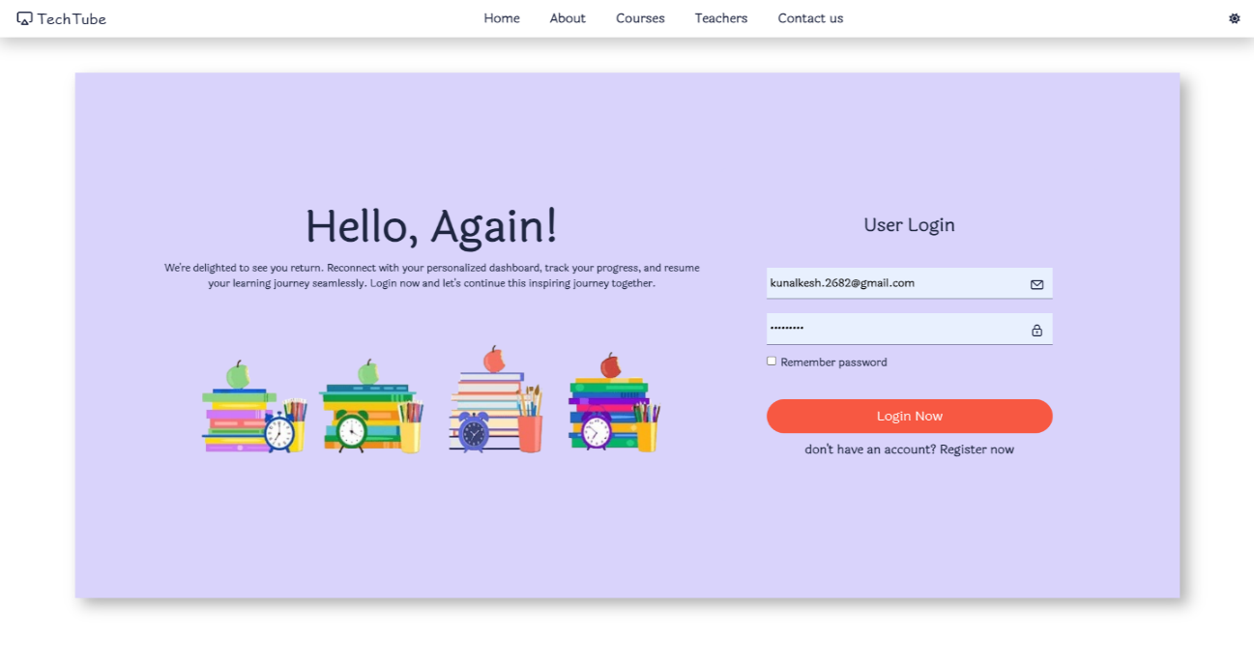

**Fig: 5.3**

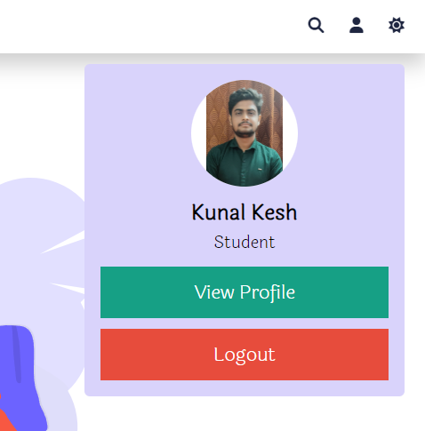

Redirects to the Profile Page, to view profile picture liked, commented & saved tutorials.

**Profile page**

**Login/Register**

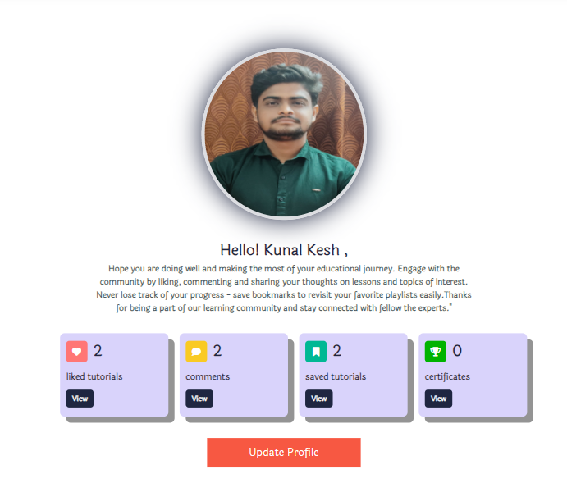

**Fig: 5.4**

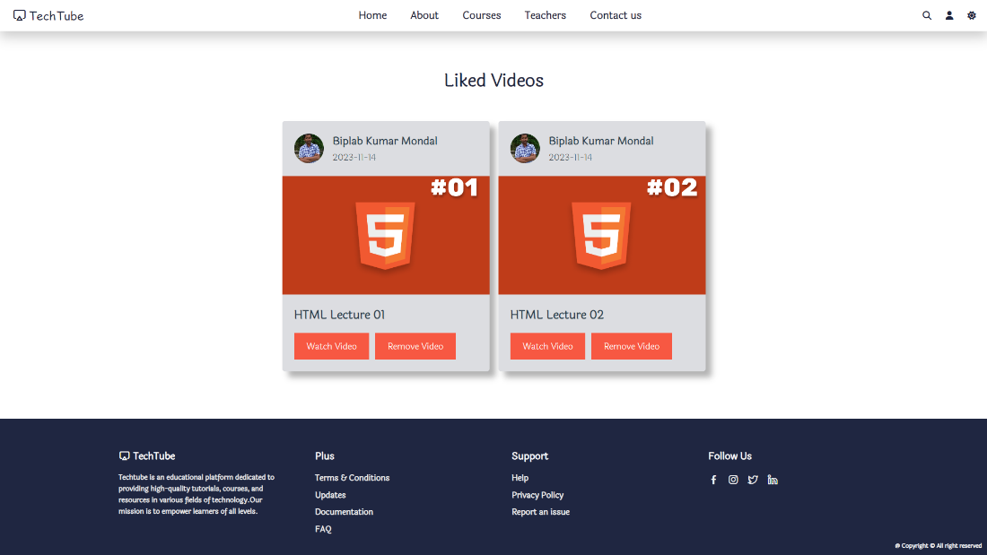

**Fig: 5.5**

**Fig: 5.6**

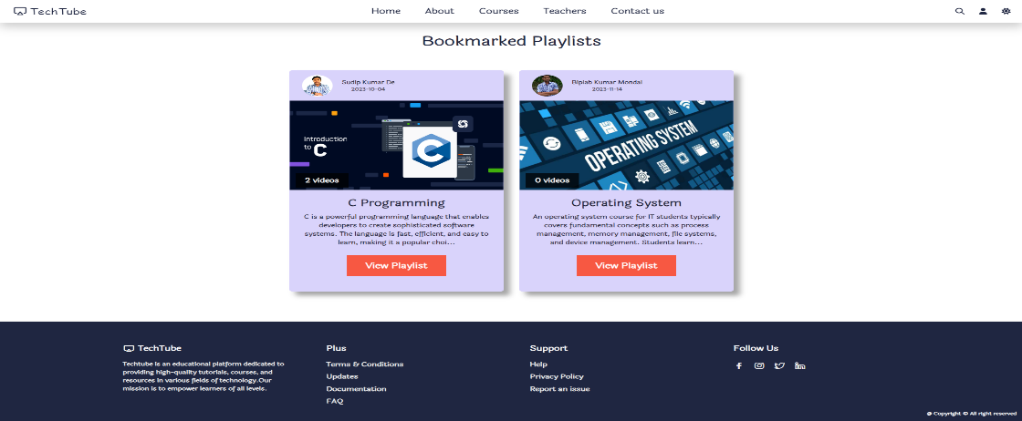

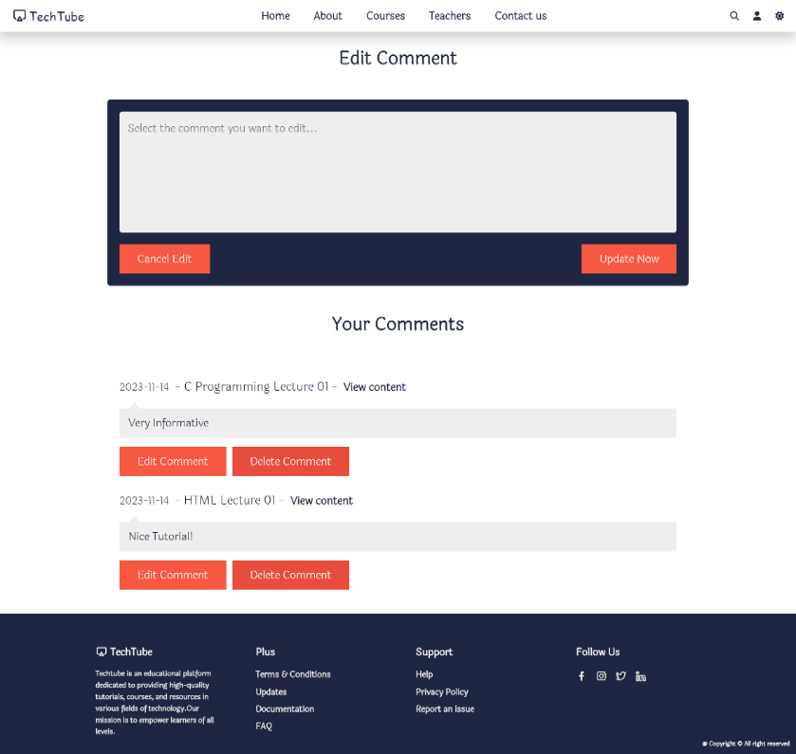

**Fig: 5.8**

**Fig: 5.7**

**Update Profile**



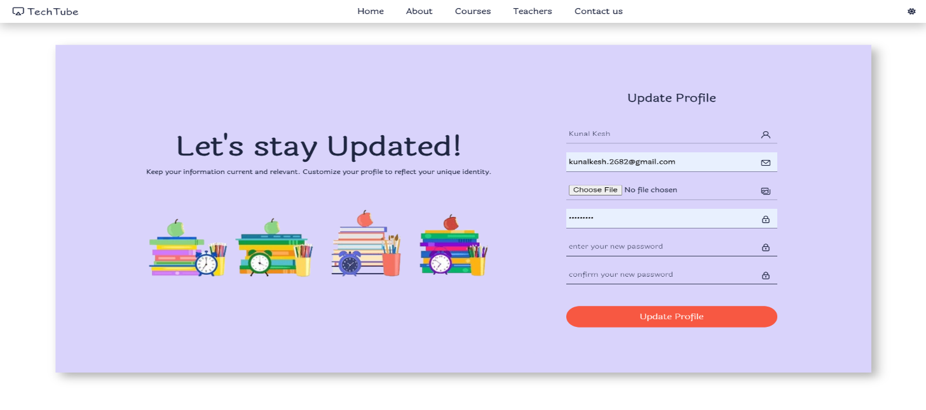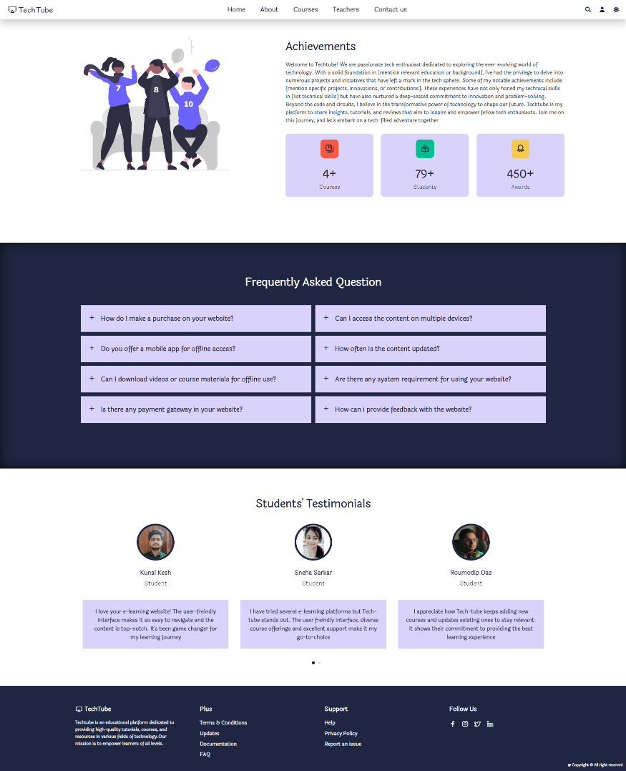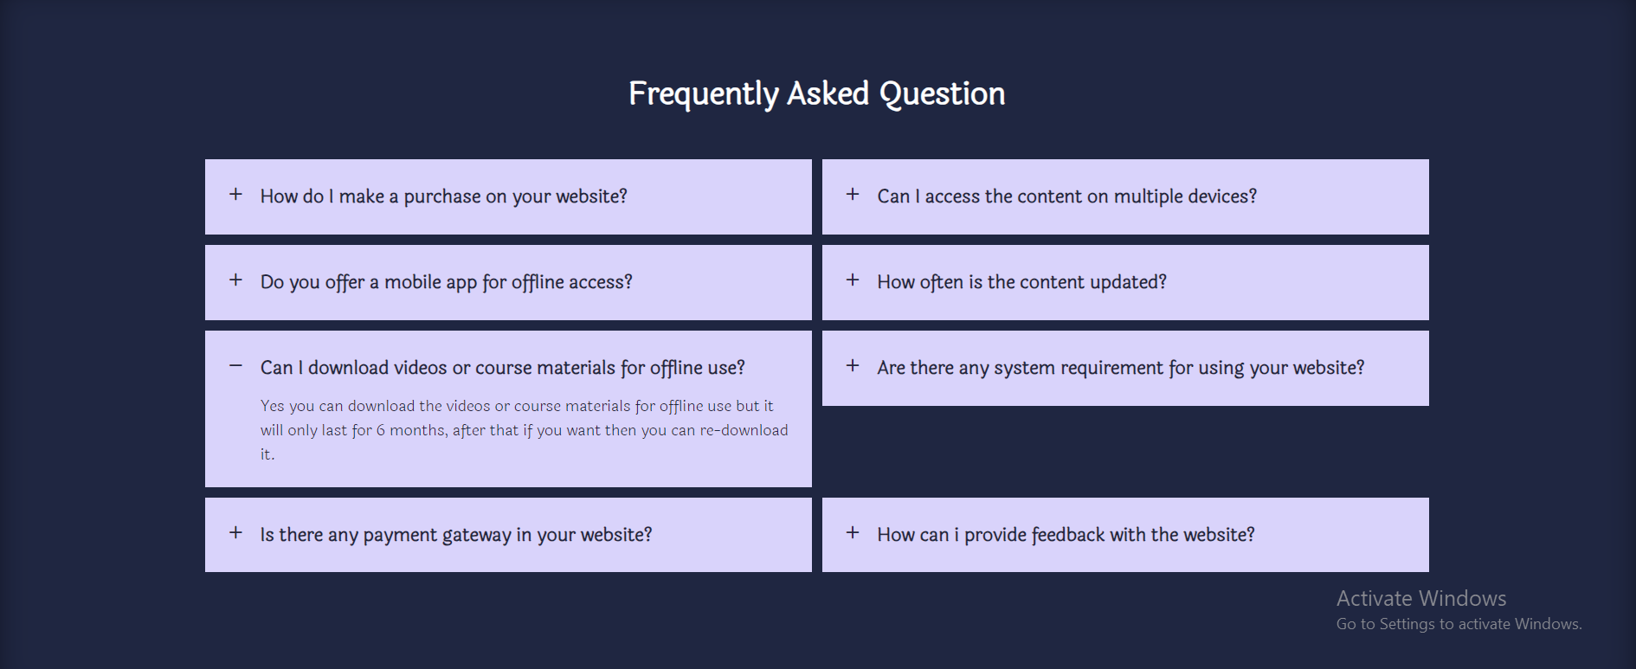 **About Page Courses Page**

**Fig: 5.9**

**Fig: 14.2**

**Fig: 6.1**

**Fig: 6**

Testimonial Section

Achievement Section

FAQs Section

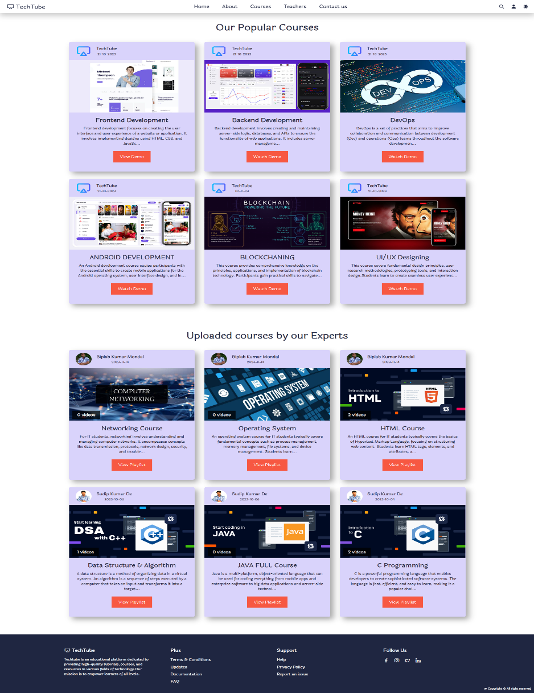

Demo video Section

Uploaded Course Section

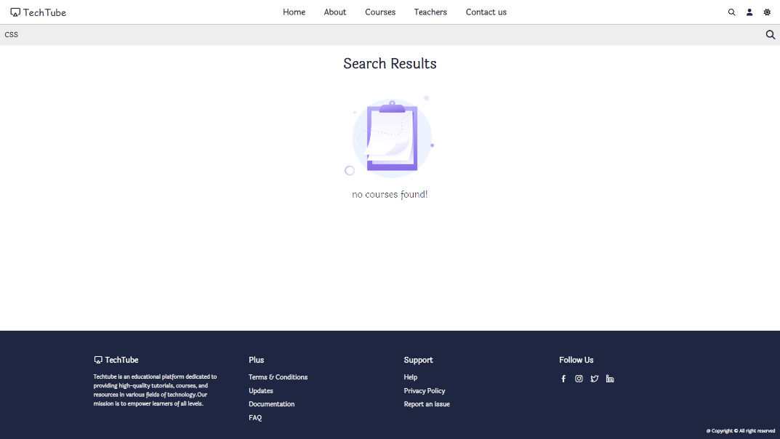

**Fig: 7**

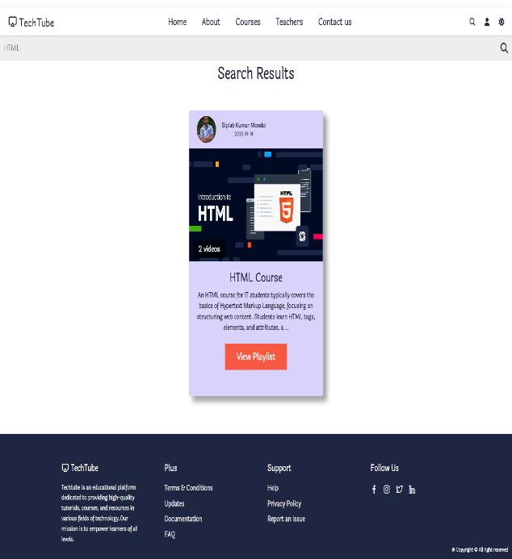

**Fig: 7.1**

**Fig: 7.2**

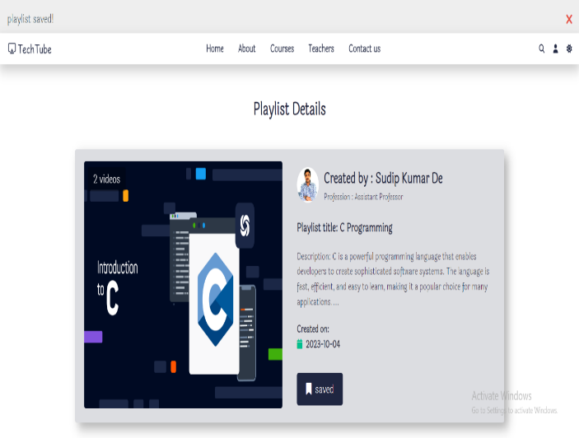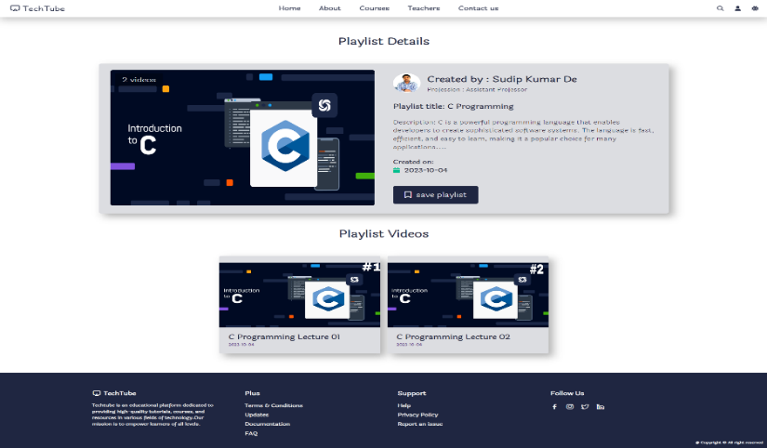

**Playlist/Watch Video page**

**Login/Register**

**Fig: 8.1**

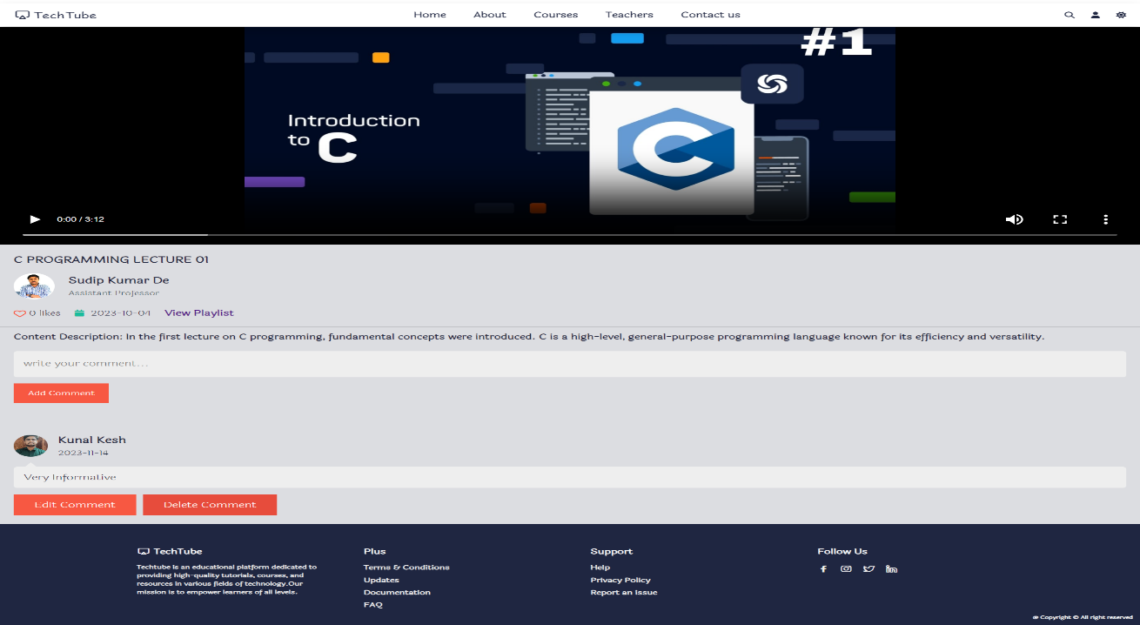

**Fig: 8**

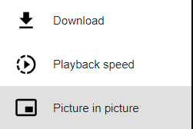

Likes Count

Comment Section

Video Control

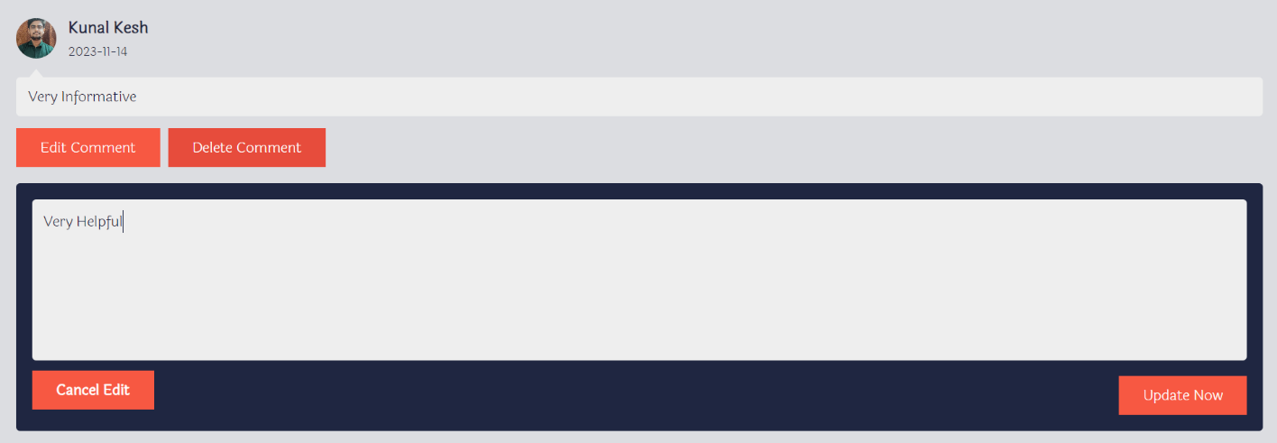

**Fig: 8.4**

**Fig: 8.3**

Edit Comments

**Teachers Page**

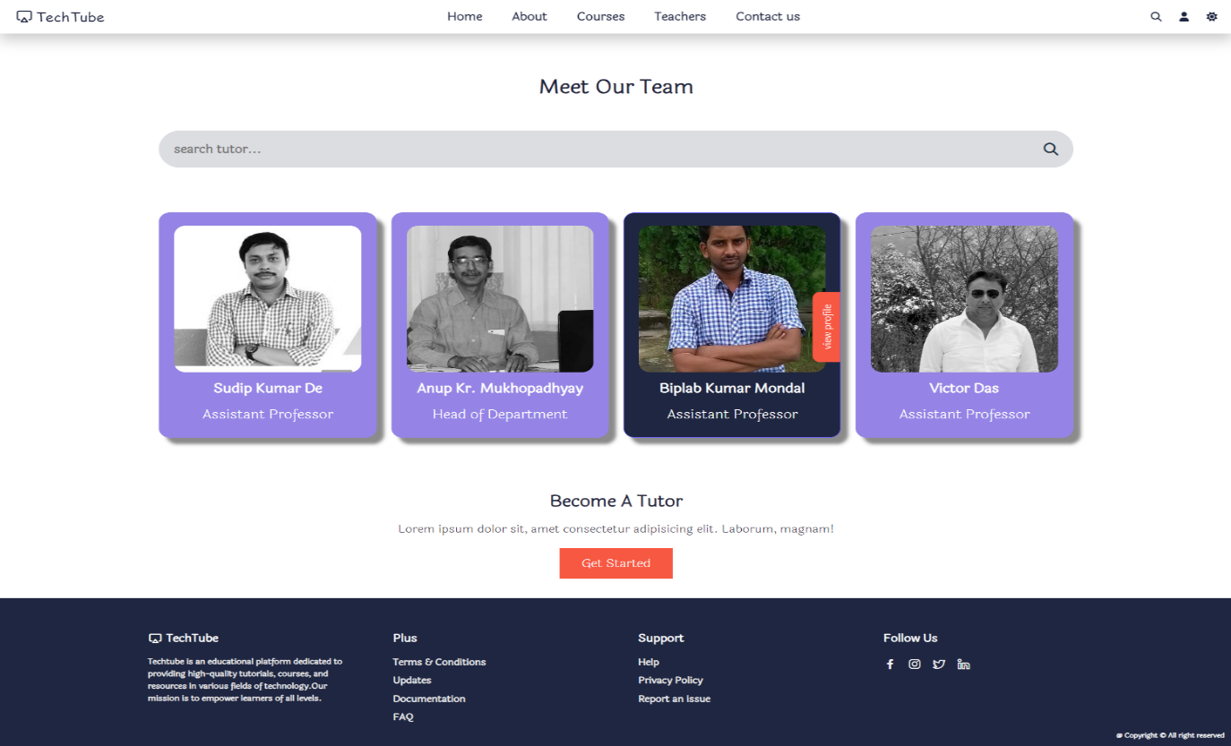

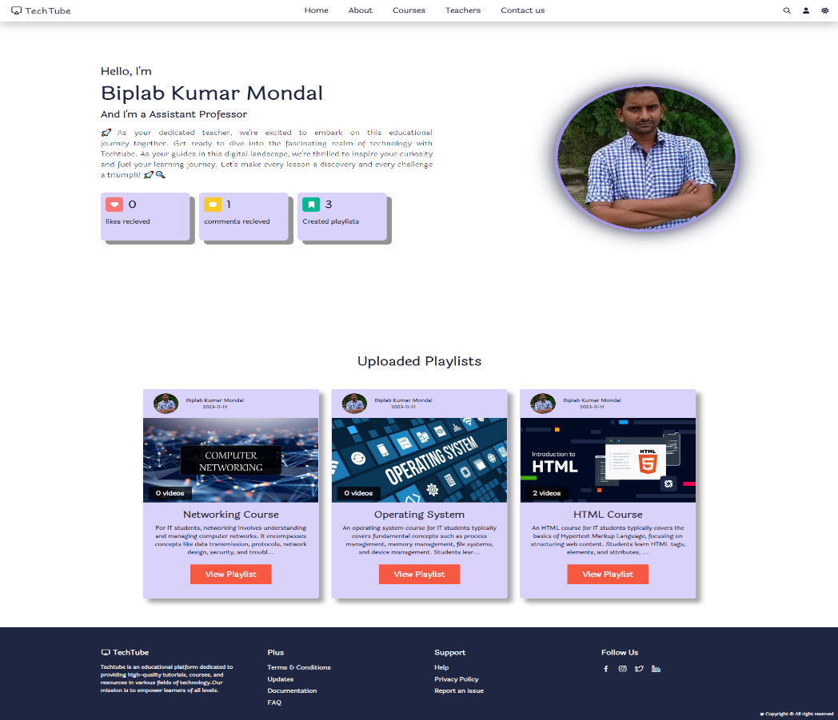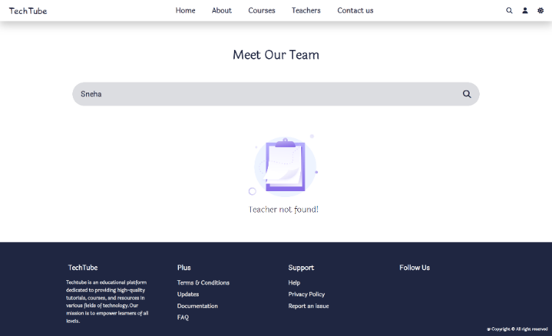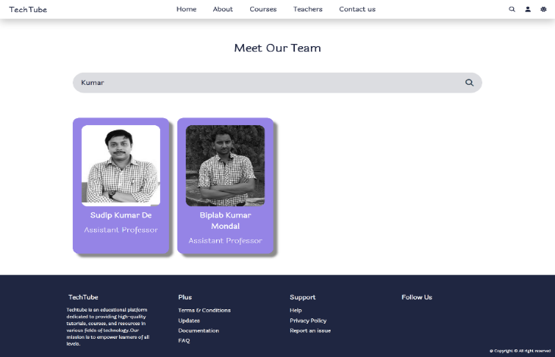

**Fig: 9.1**

**Fig: 9.3**

**Fig: 9.2**

Redirects to the teacher’s profile page

**Fig: 9**

**Contact Page**

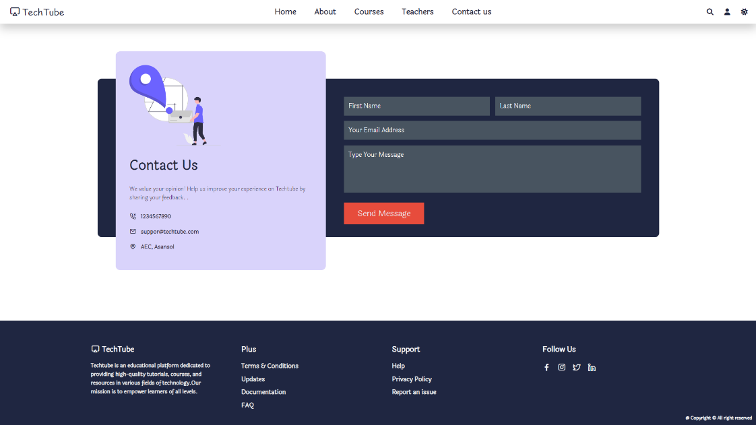

Send Queries

**Fig: 10**

**Dark Mode**

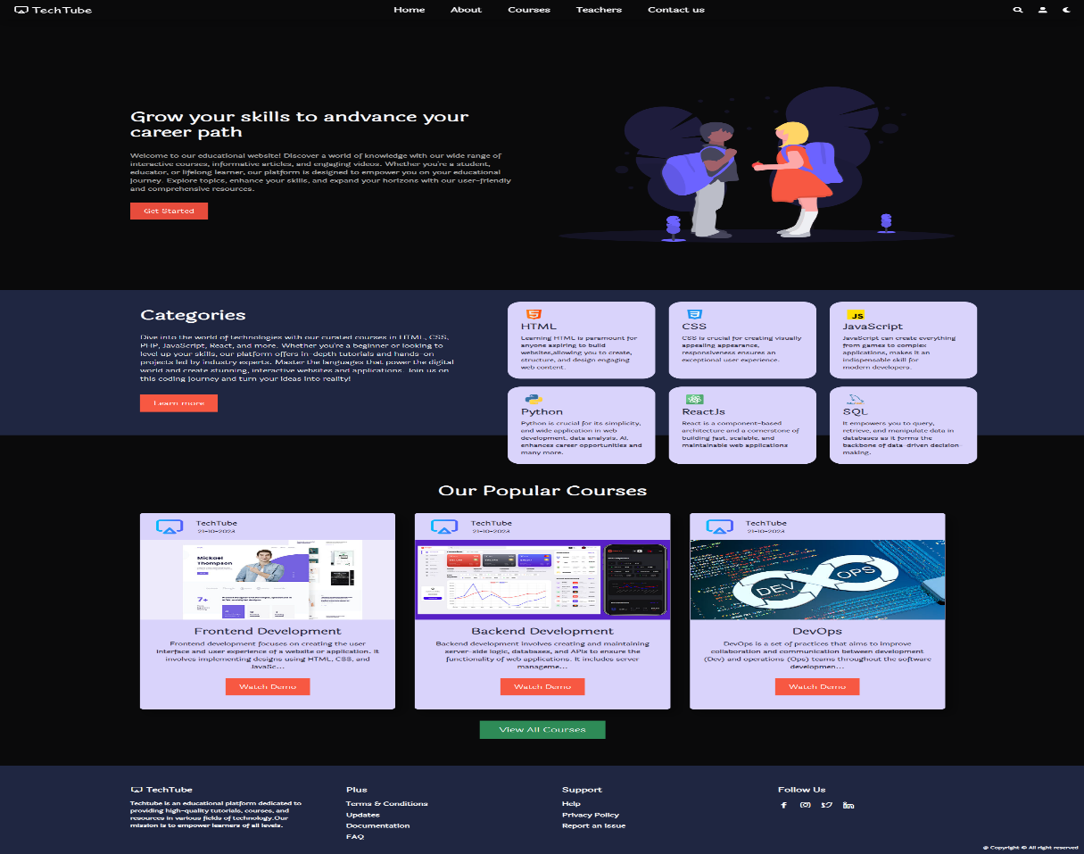

Dark Mode Enabled

**Fig: 11**

**Admin Portal:**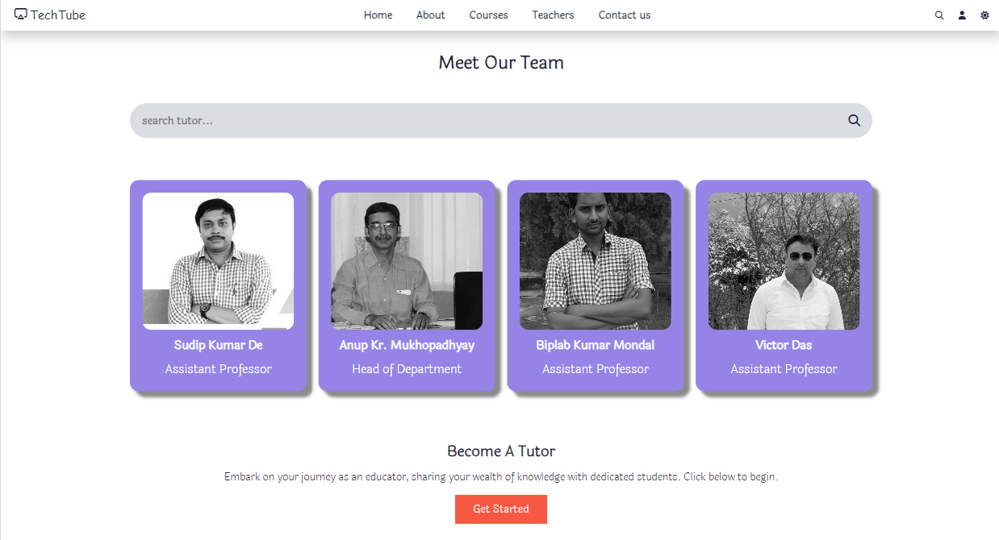

**Fig: 12**

Redirects to Login / Register Page

**Login/Register**

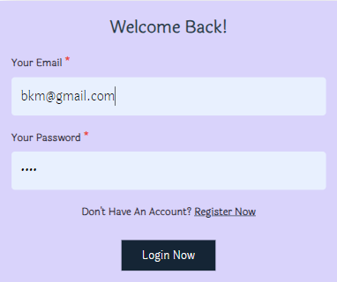 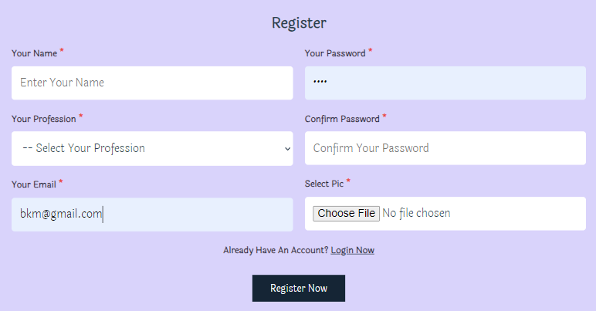

**Fig: 12.1**

**Fig: 12.2**

**Dashboard**

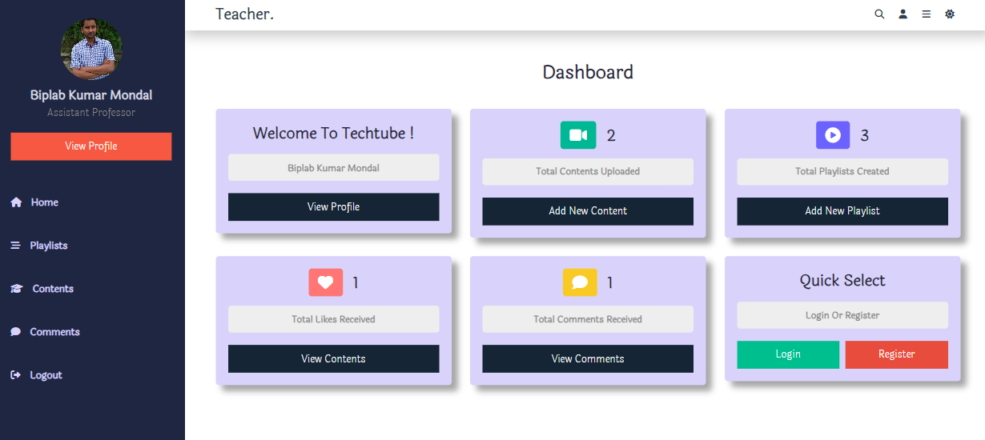

**Fig: 13**

View Contents View Comments

Redirects to Login / Register

Add New Playlist

Add New Content

Nav Bar

**Profile Page**

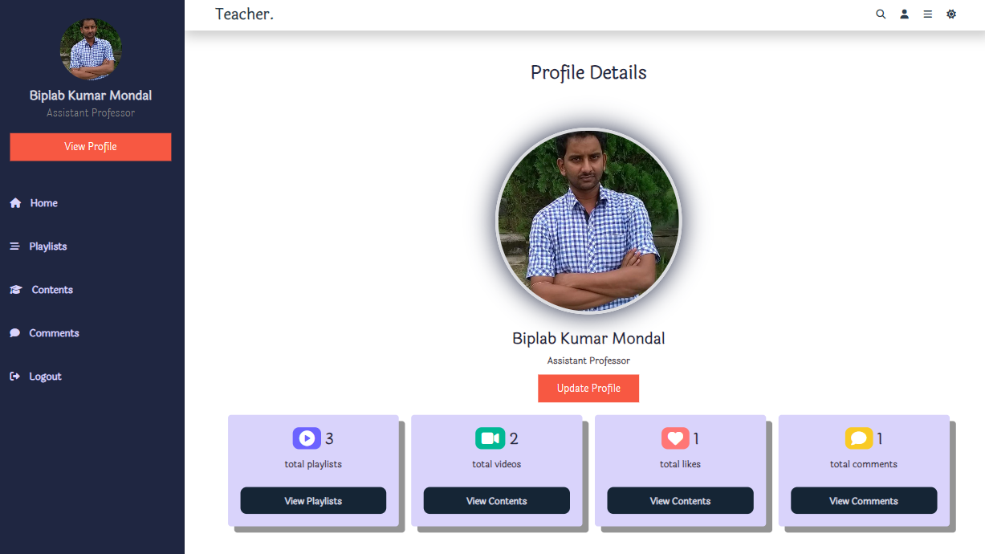

**Fig: 13.1**

View Playlists View Contents View Likes View Comments

**Playlist Page**

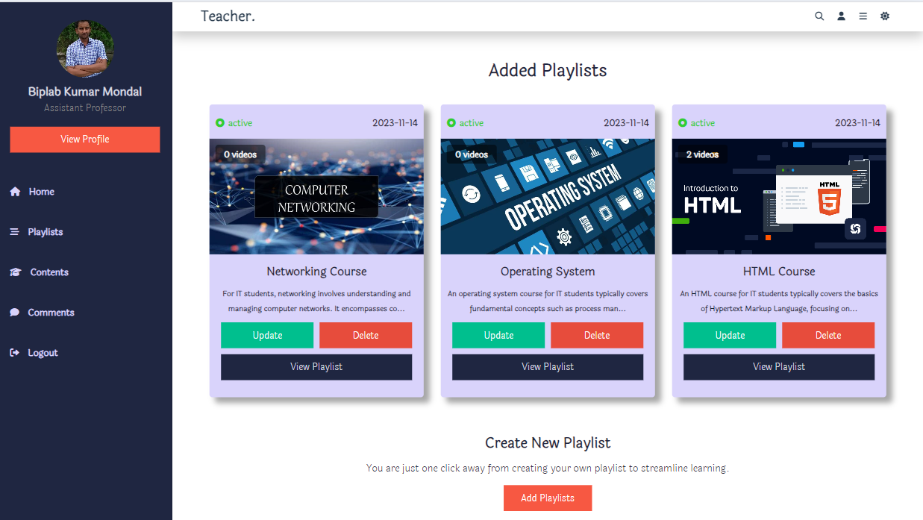

**Fig: 14**

Redirects to Add Playlist Form

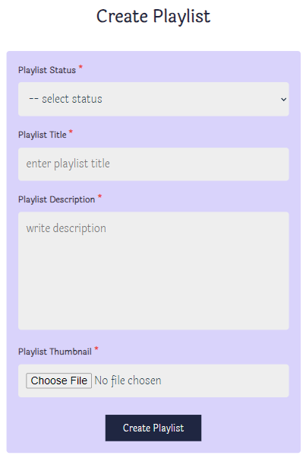

**Fig: 14.1**

Input for Playlist’s Thumbnail

Input for Playlist’s Description

Input for Playlist’s Title

Shows Status of the Playlist

**Update Playlist Page**

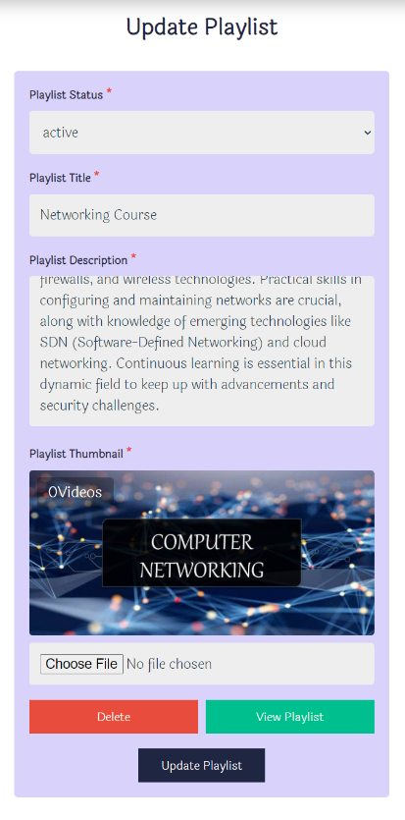

**Fig: 14.2**

Update Playlist’s Thumbnail

Update Playlist’s Description

Update Playlist’s Title

Update Status of the Playlist

**View Playlist Page**

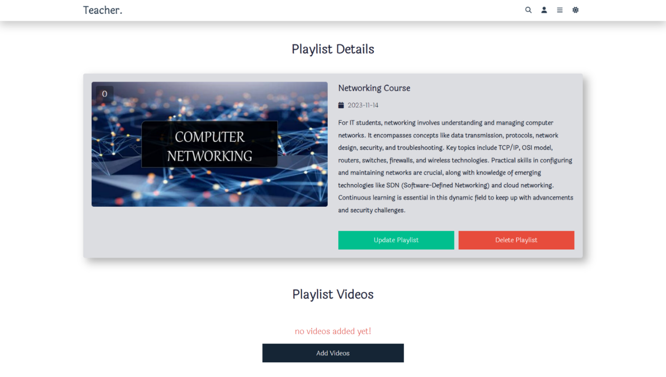

**Fig: 14.3**

**Content Page**

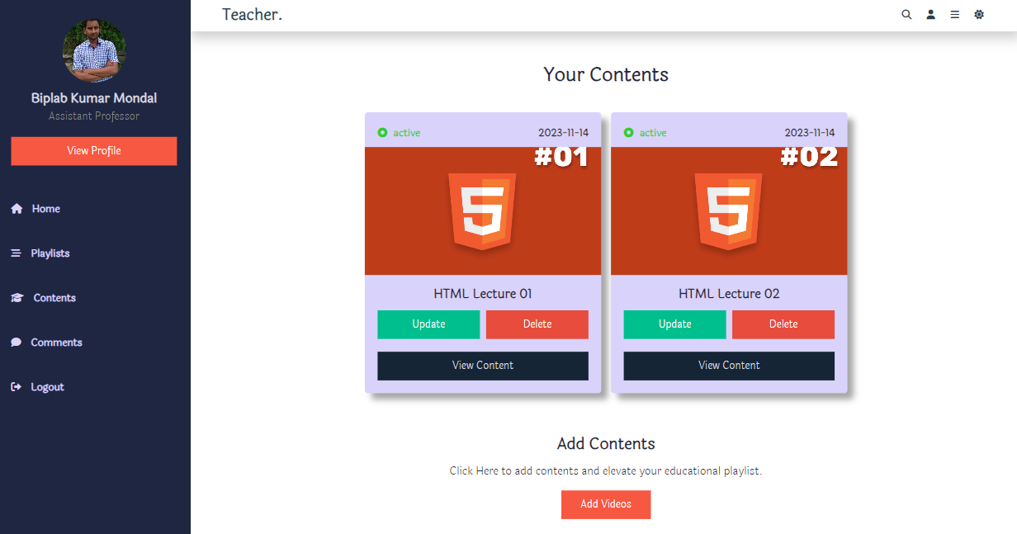

**Fig: 15**

Redirects to Update Content form

Redirects to Watch Content Page

Redirects to Upload Content form

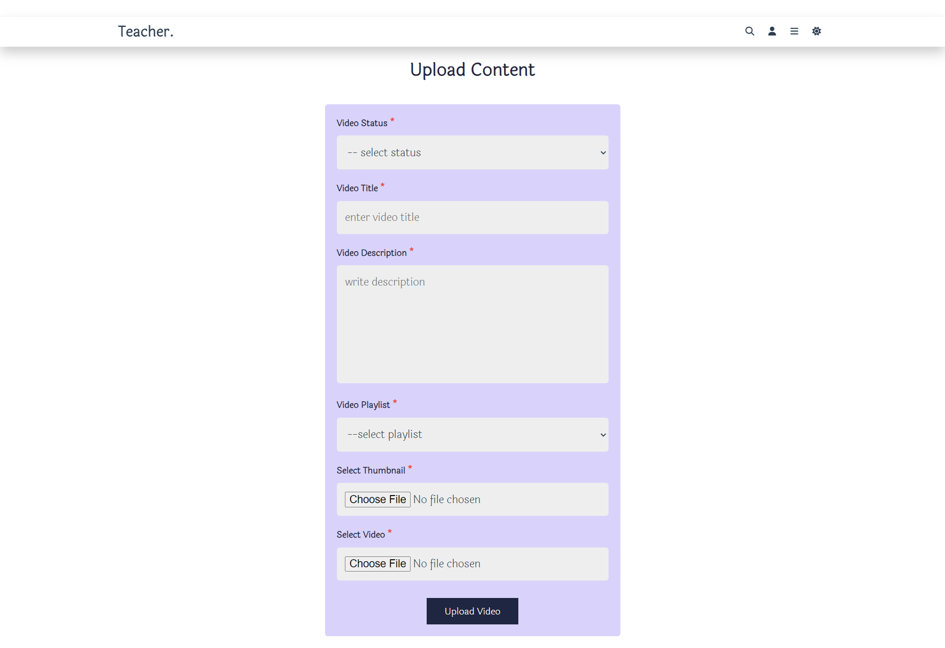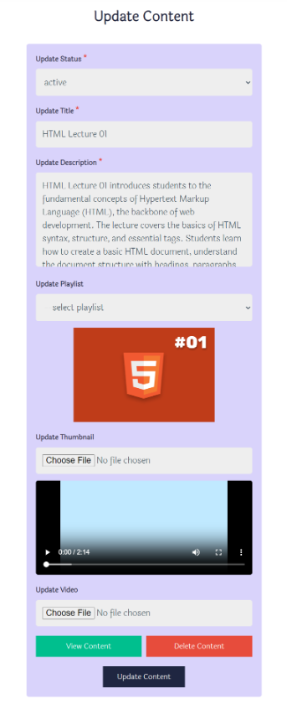

**Fig: 15.2**

**Fig: 15.1**

**Watch Content Page**

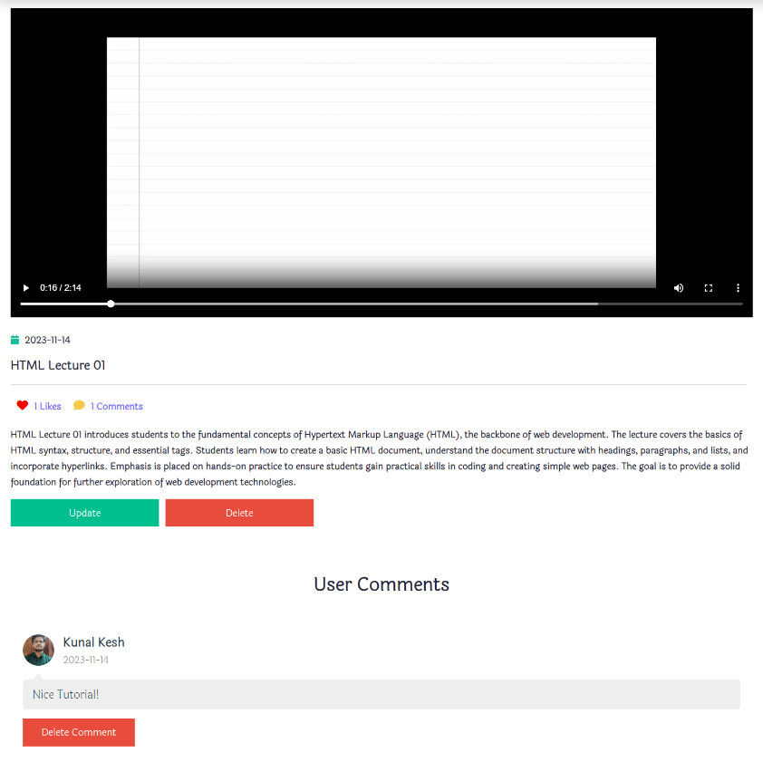

Shows User

Comments

Redirects to Update Content form

Deletes the Content

Description of the Video

Title of the Video

Watch Video

*Learn HTML with TechTube*

**Fig: 15.3**

Deletes User Comment

**Comment Page**

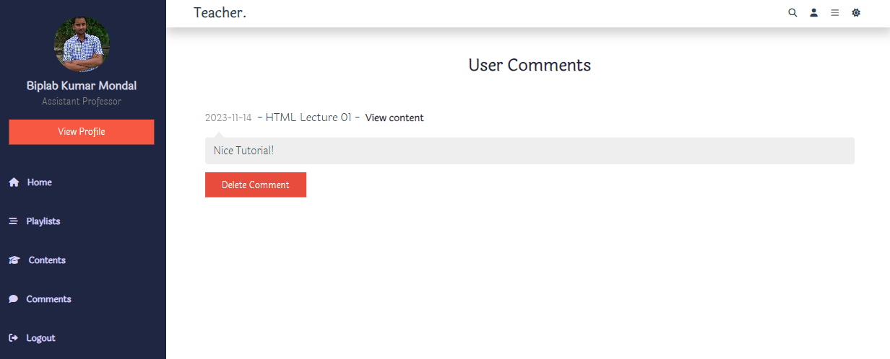

**Fig: 16**

User Log Out

Shows User Comments

**Search Bar**

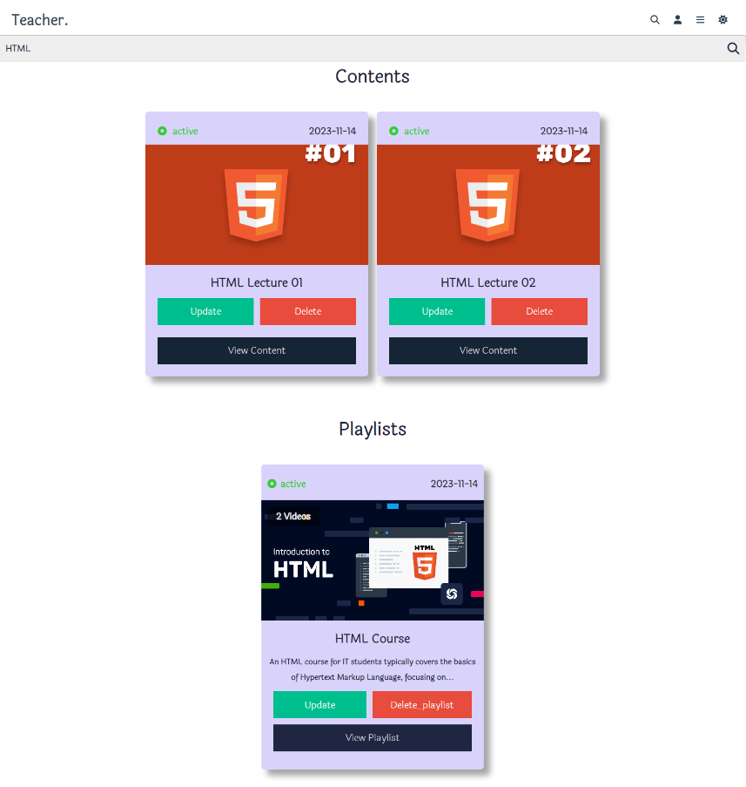

**Fig: 17**

Searches for Contents and Playlists

**Dark Mode**



**Fig: 18**

Dark Mode Applied

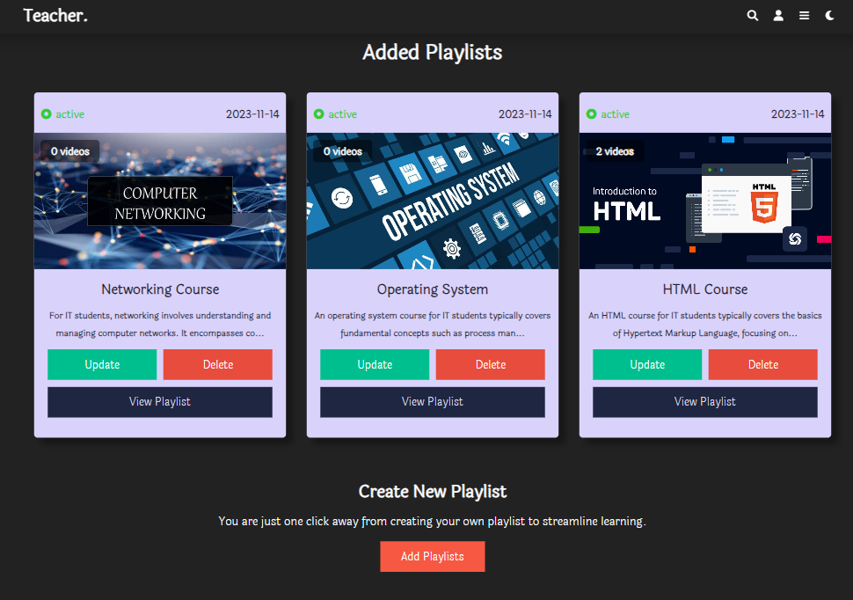

**Responsiveness Student Portal (Tab & Mobile View)**

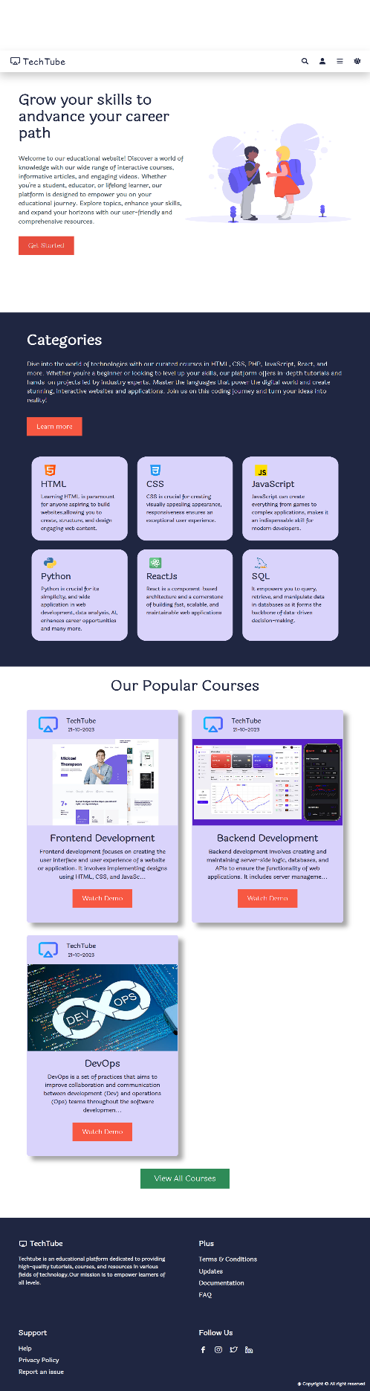

Hamburger Menu

Mobile View

IPhone SE (375 x 667)

**Fig: 19**

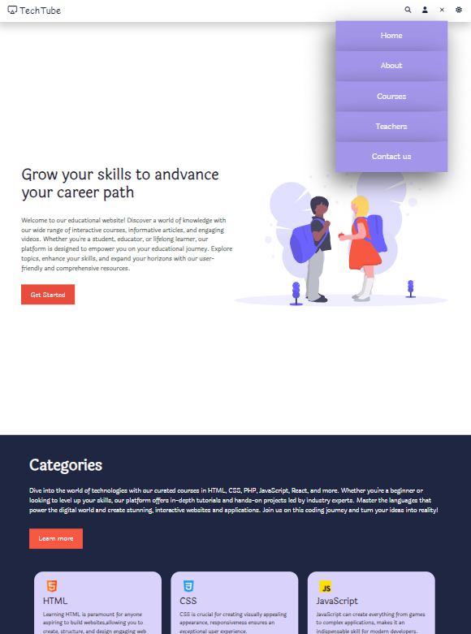

Nav Menu in Tablet View

Tablet View

IPad Pro (1024 x 1366)

**Fig: 20**

**Responsiveness Admin Portal (Tab & Mobile View)**

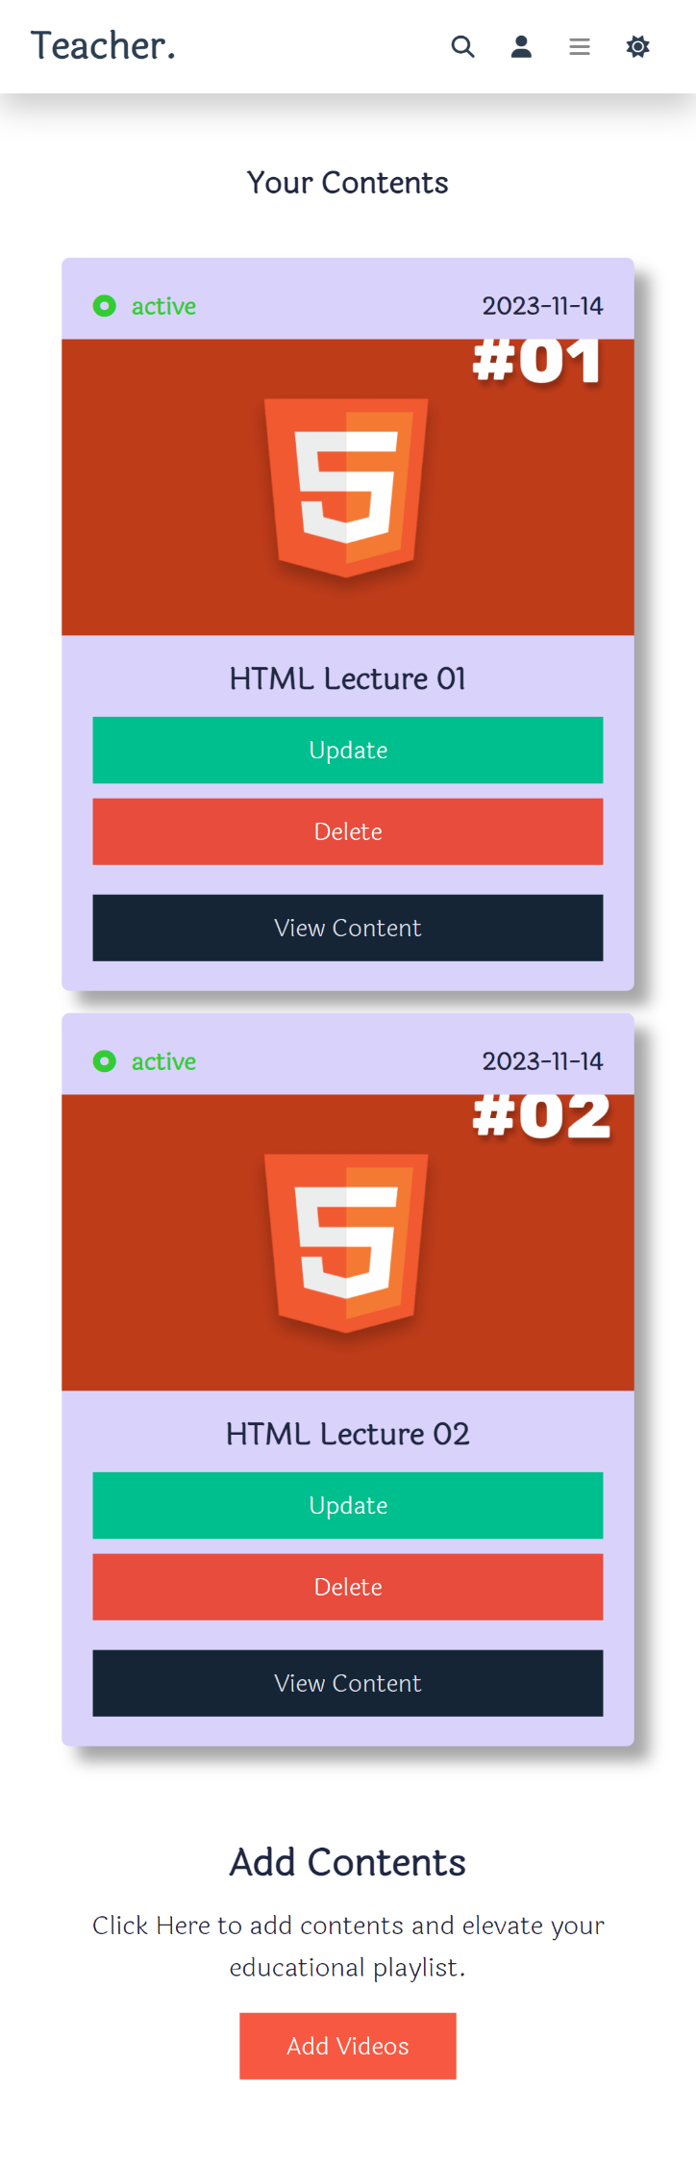

**Fig: 21**

Mobile View

iPhone SE (375 x 667)

Hamburger Menu

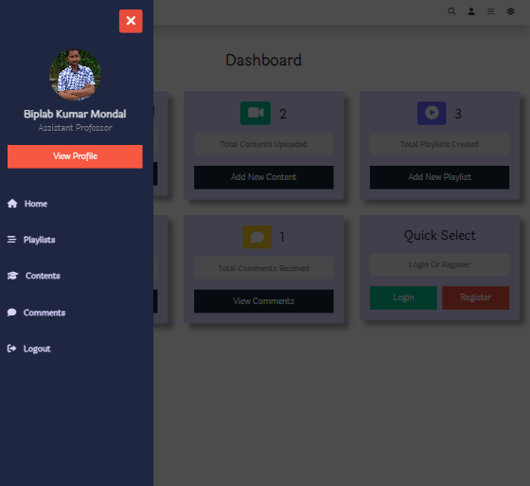

**Fig: 22**



Tablet View

iPad Pro (1024 x 1366)

**CONLUSION**

In conclusion, Techtube serves as a commendable educational website, providing a wealth of learning opportunities for users. Through its diverse array of content, ranging from tutorials and lectures to practical demonstrations, Techtube caters to a broad audience with varied learning preferences. The platform's user-friendly interface enhances the overall learning experience, allowing for seamless navigation and accessibility.

Moreover, Techtube's commitment to quality education is evident in the meticulous carnation of its content, ensuring relevance and accuracy. The inclusion of interactive features and community engagement further fosters a dynamic learning environment, encouraging collaboration and knowledge-sharing among users. As a valuable resource, Techtube not only imparts knowledge but also inspires a spirit of curiosity and continuous learning. Whether one is a novice or an expert in a particular field, Techtube stands as a reliable companion on the journey of educational exploration, making it a noteworthy platform in the realm of online education.

**FUTURE SCOPE**

The future scope of TechTube, with its innovative certificate system, is expansive and promising. By integrating automatic certificate generation contingent on successful course completion, we are poised to revolutionize online learning. This feature not only incentivizes students to genuinely engage with the course material but also ensures the credibility and value of the certification.

One key future development is the enhancement of our pop-up question mechanism. By refining the timing and difficulty of the pop-up questions, we can ensure that each student remains actively engaged and appropriately challenged. This will enhance the overall learning experience by preventing passive consumption of the content and promoting active participation.

Moreover, the integration of advanced analytics will allow instructors to gain deeper insights into student performance and engagement patterns. This can inform continuous improvement of course content and instructional strategies, leading to more effective learning outcomes.

**REFERENCE**

* [**https://flatuicolors.com/palette/defo**](https://flatuicolors.com/palette/defo)
* [**https://www.flaticon.com/**](https://www.flaticon.com/)
* **https://www.youtube.com**
* [**https://www.pngegg.com/**](https://www.pngegg.com/)
* **https://fonts.google.com/**
* [**https://storyset.com/**](https://storyset.com/)
* [**https://cdnjs.com/libraries/font-awesome**](https://cdnjs.com/libraries/font-awesome)
* [**https://swiperjs.com/**](https://swiperjs.com/)
* [**https://unicons.iconscout.com/release/v2.1.6/css/unicons.css**](https://unicons.iconscout.com/release/v2.1.6/css/unicons.css)
* **https://formspree.io/**